**GIT Commands and explanation**

1. Cmd: **git - -version**

Displays the version of the git installed in the windows.



1. Cmd: **git checkout <branch_name>**

Switch to mentioned branch from current branch. Below it switched to branch “main”



1. Cmd: **git branch**

Lists all the branches present. And current branch prefixed with *.

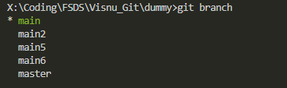

1. Cmd: **git branch –M <new_branch_name>**

It renames the current branch name to new branch name.

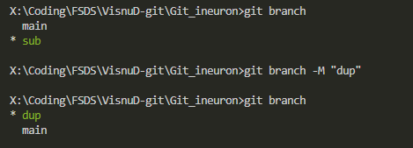

1. Cmd: **git status**

Displays the status of current branch like branch name, details of files, etc.

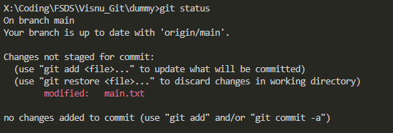

1. Cmd : **git add <file_name>**

Stage the mentioned file. We can also provide dot(‘.’) after add to stage all the files in current branch. As below

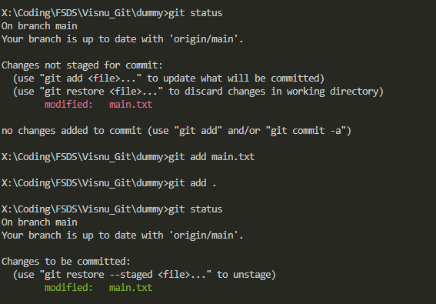

1. Cmd: **git clone <github_repo_link>**

It downloads complete repository from github to local directory.

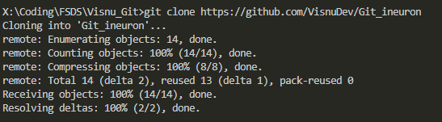

1. Cmd: **git commit –m “commit message”**

It saves all the staged changes along with a commit message.

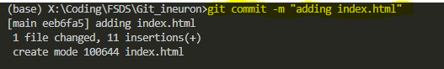

1. Cmd: **git push origin main**

It pushes or upload the local main branch in local to remote git-hub original branch.

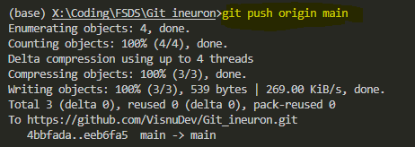

1. Cmd: **git init**

To convert a normal repository to git repository.



1. Cmd: **git config –global user.name**

To display the username configured with git



1. Cmd: **git config –global user.email**

To display the email configured with git



1. Cmd: **git config –global user.email <email>**

To configure the git email



1. Cmd: **git config –global user.name <username>**

To configure the git username



1. Cmd: **git merge <branch_name>**

To merge the mentioned branch to current branch

